SCHOOL OF COMPUTER SCIENCE AND ARTIFICIAL INTELLIGENCE |  |  |  |  | DEPARTMENT OF COMPUTER SCIENCE ENGINEERING
ProgramName:B. Tech |  |  |  | Assignment Type: Lab |  |  | AcademicYear:2025-2026
Course Coordinator Name |  |  |  | Venkataramana Veeramsetty
Instructor(s)Name |  |  |  | Dr. V. Venkataramana (Co-ordinator)  Dr. T. Sampath Kumar  Dr. Pramoda Patro  Dr. Brij Kishor Tiwari  Dr.J.Ravichander  Dr. Mohammand Ali Shaik  Dr. Anirodh Kumar  Mr. S.Naresh Kumar  Dr. RAJESH VELPULA  Mr. Kundhan Kumar  Ms. Ch.Rajitha  Mr. M Prakash  Mr. B.Raju  Intern 1 (Dharma teja)  Intern 2 (Sai Prasad)  Intern 3 (Sowmya)  NS_2 ( Mounika)
CourseCode |  |  | 24CS002PC215 | CourseTitle |  | AI Assisted Coding
Year/Sem |  |  | II/I | Regulation |  | R24
Date and Day  of Assignment |  |  | Week1 - Thursday | Time(s)
Duration |  |  | 2 Hours | Applicableto  Batches |  | 24CSBTB01 To 24CSBTB39
AssignmentNumber:1.4(Present assignment number)/24(Total number of assignments)
 | Q.No. | Question |  |  |  |  |  | ExpectedTime  to complete
 | 1 | Lab 1: Environment Setup – GitHub Copilot and VS Code Integration  Lab Objectives:  - To install and configure GitHub Copilot in Visual Studio Code.  - To explore AI-assisted code generation using GitHub Copilot.  - To analyze the accuracy and effectiveness of Copilot's code suggestions.  - To understand prompt-based programming using comments and code context  Lab Outcomes (LOs):  After completing this lab, students will be able to:  - Set up GitHub Copilot in VS Code successfully.  - Use inline comments and context to generate code with Copilot.  - Evaluate AI-generated code for correctness and readability.  - Compare code suggestions based on different prompts and programming styles.  Task Description #1  • Install and configure GitHub Copilot in VS Code. Take screenshots of each step.  Expected Output #1  • Successfully install and activate GitHub Copilot in VS Code. Include screenshots showing installation, authentication via GitHub, and an example suggestion from Copilot.  Task Description #2  • A function in Python that returns the maximum of three numbers using GitHub Copilot. Use an appropriate comment as a prompt.  Expected Output #2  • Python function that takes three inputs and returns the largest value. Include the code and output.  Task Description #3  • Use GitHub Copilot to create a recursive Python function that calculates the factorial of a number.  Expected Output #3  • Python function for factorial using recursion with input and output examples.  Task Description #4  • Prompt GitHub Copilot to create a class named Student with attributes name, roll_no, and marks. Add a method to display student details.  Expected Output #4  • Python class definition with an initializer and a display method. Include object creation and output.  Task Description #5  • Ask GitHub Copilot to generate a Python function that takes a string as input and returns the frequency of each word.  Expected Output #5  • Python function that returns word frequency using a dictionary. Provide sample input and output.  Note: Report should be submitted a word document for all tasks in a single document with prompts, comments & code explanation, and output and if required, screenshots  Evaluation Criteria:  Criteria Max Marks  Install and configure GitHub Copilot in VS Code (Task #1) 0.5  Python function that takes three inputs and returns the largest value (Task #2) 0.5  Python function for factorial using recursion (Task #3) 0.5  Python class definition with an initializer and a display method (Task #4) 0.5  Function that returns word frequency using a dictionary (Task #5) 0.5  Total 2.5 Marks |  |  |  |  |  | Week1 - Thursday

Task Description #2
• A function in Python that returns the maximum of three numbers using GitHub Copilot. Use an appropriate comment as a prompt.

Prompt: create a python funtion taking three numbers from the console and compare the numbers and find the largest number and print it on the console and take input from the console

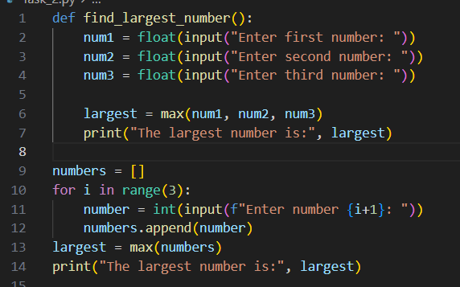
Output:
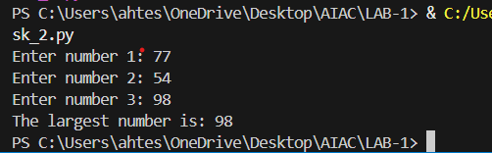

Task Description #3
• Use GitHub Copilot to create a recursive Python function that calculates the factorial of a number.
Prompt: create a recursive Python function taking the input from the console and calculates the factorial of a number then after that print it on the console
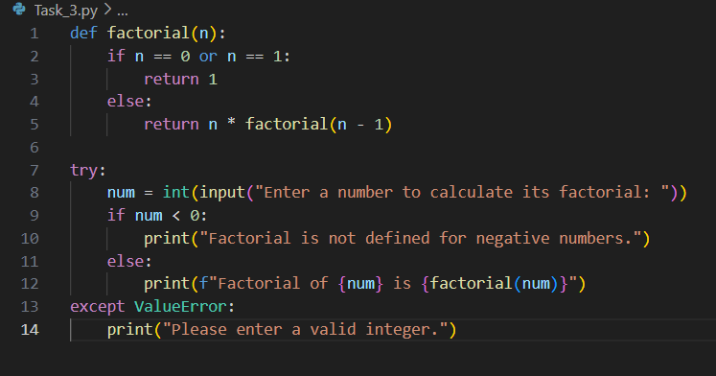

Output:
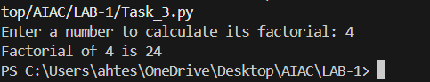

Task Description #4
• Prompt GitHub Copilot to create a class named Student with attributes name, roll_no, and marks. Add a method to display student details.
Prompt: create a class named Student with attributes name, roll_no, and marks. Add a method to display student details by taking input from the console.
Python class definition with an initializer and a display method. Include object creation and output.

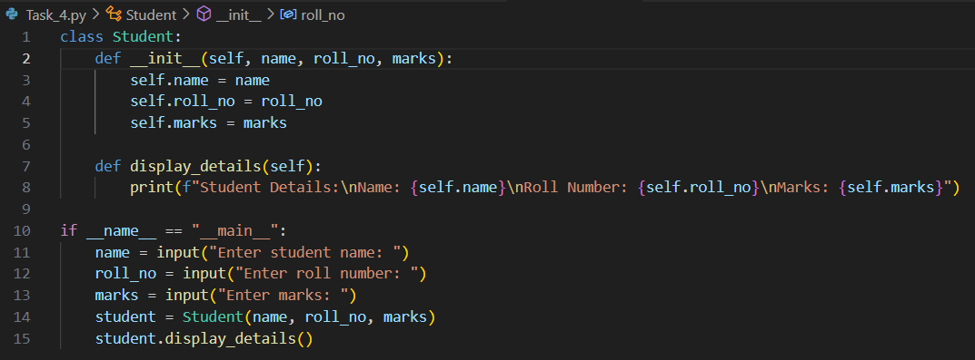

Output:
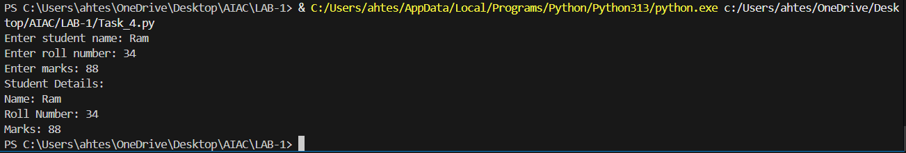

Task Description #5
• Ask GitHub Copilot to generate a Python function that takes a string as input and returns the frequency of each word.
Prompt: create a python function that takes a string from the console as input and returns the frequency of each word using dictionary.
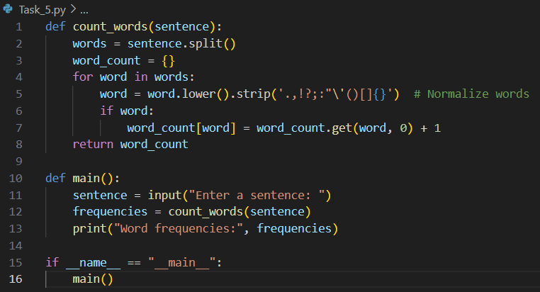

Output:
